Final Report:  
Using Gaze Input to Navigate a Virtual Geospatial Environment

# Overview

With recent updates in hardware and software, it is now possible to perform real-time eye tracking for relatively low cost. As technology improves in the next few years, gaze input has great potential to be among the next revolutionary input mechanisms – either on its own or as a supplement to other input devices. As humans naturally use gaze as a means of interacting with and exploring their environment, using gaze as an input channel for navigation in a *virtual* environment seems like a logical progression. In the context of a virtual globe application, that means manipulating the camera to give the user a better view of where they are currently interested. In this work, we developed a prototype geospatial application which utilized a gaze-based user interface (UI) overlay for pan and zoom control. User testing was conducted to measure the qualitative and quantitative effectiveness of this design. XXXX participants completed sequential geographic search tasks using an SMI RED250 eye tracking system.

# Introduction

While previous work has been done in the field of gaze-based input for panning and zooming (including both geospatial applications as well as navigation of dense two-dimensional images), this prototype also implemented an *adaptive* technique for pan control. As users zoomed in closer the pan controls changed from edge-of-screen based to center-of-view based. The intent behind this design was to provide an optimal user interface which would adapt itself to reflect the user’s interest in a more focused geographic region. See Figure 1 and Figure 2.

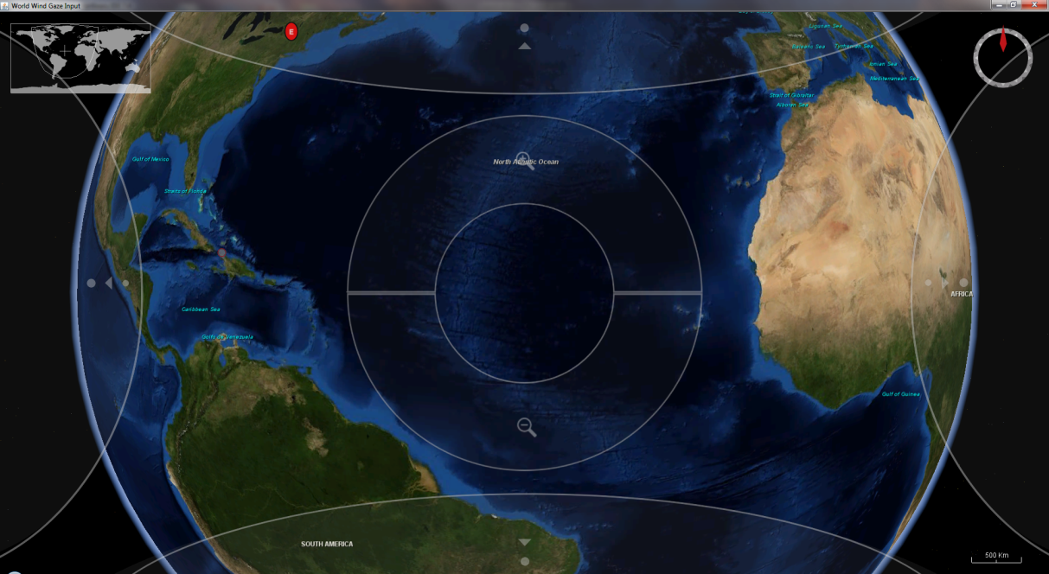

Figure 1 - Gaze UI for globe navigation, zoomed out

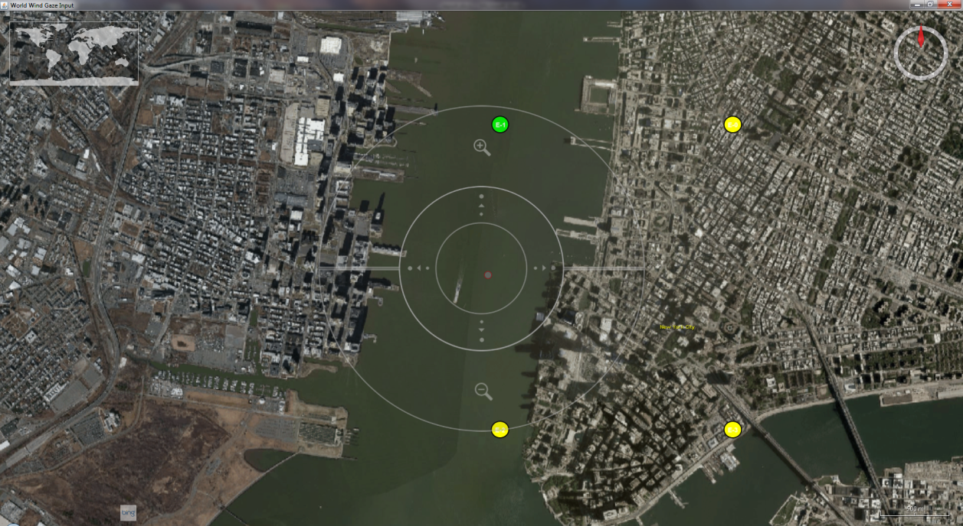

Figure 2 - Gaze UI for globe navigation, zoomed in

The edge-of-screen panning UI can be used for gross panning over broad areas, for instance navigating across the globe between continents. The map panning behavior was faster in this mode, covering large distances in a relatively short amount of time (exact distance was still dependent on zoom). The center-of-view panning UI is for finer control over the pan, allowing the camera to be moved among individual cities or streets. Pan speed was slowed down to half that of the other panning mode.

This design choice was made to test a hypothesis that, at closer zoom levels, users would be more interested in panning the map in small increments and keeping their gaze focused closer to the center of the screen. This would facilitate search patterns looking for finer detail, such as individual buildings and streets. At further zoom levels, it is assumed that users are more interested in a “regional” level of panning; that is, panning in large, gross movements to get from one major region to the other.

The application prototype was built using NASA World Wind version 2.0. World Wind is an open-source 3D virtual globe application, developed by NASA, which exposes an API in Java using the Swing GUI framework (<http://www.goworldwind.org>).

# Prior Work

## Primary Reference

This project was built primarily on prior work published by Stellmach, et al for the 2012 Eye Tracking Research and Applications conference [XXXXX] [XXXXX] as well as Adams, et al for the 2008 Conference on Advanced Visual Interfaces. [XXXXX]

In the first part of Stellmach’s work, the authors developed and tested systems for providing gaze input as a means of control of a 3D virtual environment. [XXXXX] They felt gaze could serve as a natural way for a user to navigate such a space. They conducted two rounds of testing with several varying designs, the second round built on the first by revising and improving on the initial gaze-based interface.

Stellmach, et al used a means of input where point-of-regard was mapped to a gradient-based image overlay to provide different kinds of controls to the user. Continuous feedback was provided for dwell-based activation of “hot” regions. The figure below illustrates their final design after testing several revisions.

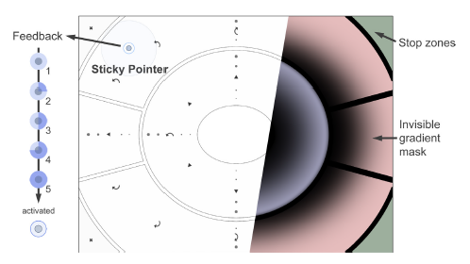

Figure 3 - Illustration of control regions and behavior used by Stellmach, et al [XXXX]

This capstone project will use a very similar design for interpreting gaze input. The primary difference will be in the exploration of these concepts in a *geospatial* context. Where Stellmach, et al performed their experiments in a more artificial 3D scene, this project will place users within a 3D virtual globe environment and ask them to navigate to specific geographic locations or landmarks using gaze.

Adams’ work focused on XXXXXXXXXXXXXXXXXXXXXXXXXXXXXXXX

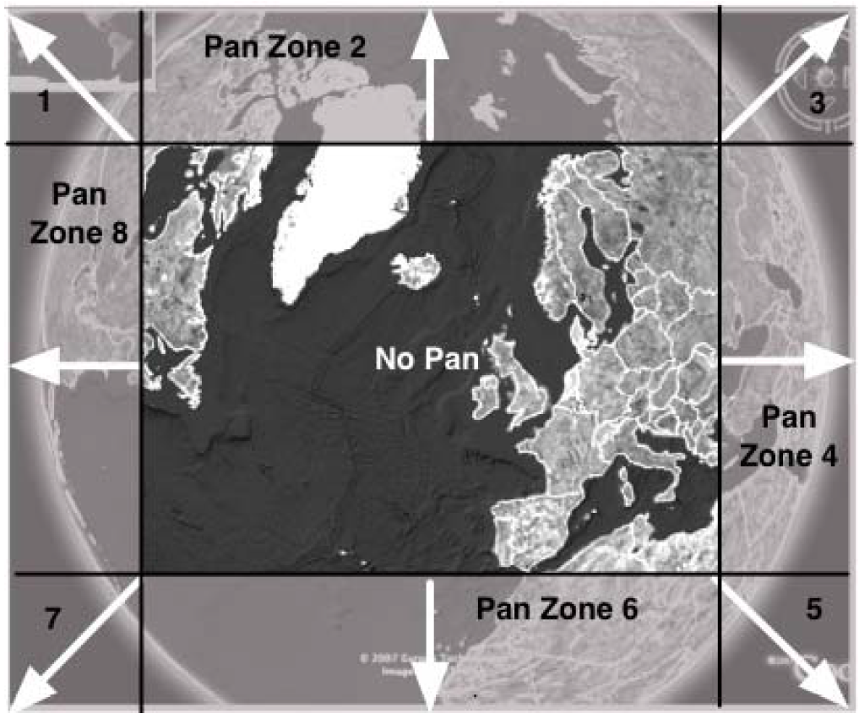

Figure - UI layout of Adams' gaze input application

## Other Research

Research surrounding techniques and applications for eye tracking are abundant and an exhaustive review would be beyond the scope of this report. Even specifically looking at applications for *gaze input*, a great deal of research has been done and a full review is excessive here. However, if we look explicitly at research and applications concerned with using *gaze input* *for navigation and control of virtual environments*, we can begin to narrow the body of work and focus on key insights that contributed to this project.

As early as 1990, Jacob has published work discussing methods of interaction using eye movement. [XXXXX] Here he describes the design and user testing of techniques for object selection, object manipulation, eye-controlled text scrolling, and accessing menu commands. These techniques were implemented and tested on a display for visualizing ship locations on a geographic naval display. Directly applicable to this project is his finding that users greatly prefer a method of object selection based on dwell time, rather than a push-button technique. [XXXXX] Since the interface design in this project implemented a kind of “push-button” technique for navigation, versus a dwell-based technique, our findings here will help to either enforce or contradict Jacob’s findings. This depends largely on qualitative user performance and feedback results from our user evaluations.

Similarly in 2000, Tanriverdi and Jacob published further work looking at gaze-based interaction techniques in *virtual environments.* [XXXXX] The output apparatus tested was similar to a virtual reality simulator, but users controlled movement using their eyes and gaze rather than any manual controls. Here the findings supported gaze as a much faster method of interaction, providing more command bandwidth between the human and the machine. However their participants had less of an ability to recall spatial information when using gaze. [XXXXX]

Other related work in using gaze to interact in virtual environments, specifically third-person perspective games, includes that conducted by Smith and Graham **Error! Reference source not found.**; Vickers, et al **Error! Reference source not found.**; Istance, Vickers, et al **Error! Reference source not found.**; and Istance, Hyrskykari, et al **Error! Reference source not found.**.

One commonality among this research is that the Midas Touch problem has been demonstrated to be a large barrier in the successful implementation of gaze input interfaces. This problem is described from early work in the field. **Error! Reference source not found.** Recent work that has attempted to solve this problem includes the “Snap Clutch” method proposed by Istance, Bates, et al. **Error! Reference source not found.** This technique allows the user to quickly switch into and out of “gaze mode” so that gaze input can be seamlessly switched on and off. This is one technique that could have enhanced performance in our research, and future modifications specifically in avoiding Midas Touch could help to improve the user experience of our application.

# Project Details

## Phase 1 and 2 – Kinect as an eye Tracking System

As specified in the project proposal, an attempt was made during the initial portion of this project to utilize the Microsoft Kinect system as an eye tracker. Because this system included both an IR and RGB camera, it could in theory have been coupled with the open source GazeTracker software to track a user’s gaze. The GazeTracker software was modified to allow video input from the Kinect system. This involved modification of the C# source code using the freely-available application programming interface (API) provided for the Kinect system by Microsoft.

Once the Kinect’s infrared camera feed was successfully integrated into the GazeTracker processing algorithm, the entire system was tested. As part of the deliverable package for this project, the modified GazeTracker software can be found here: XXXXXXXXXXXXXXX. Additionally, the figure below illustrates a high level design of this software.

### Design – MOdifications to open source ITU GazeTracker

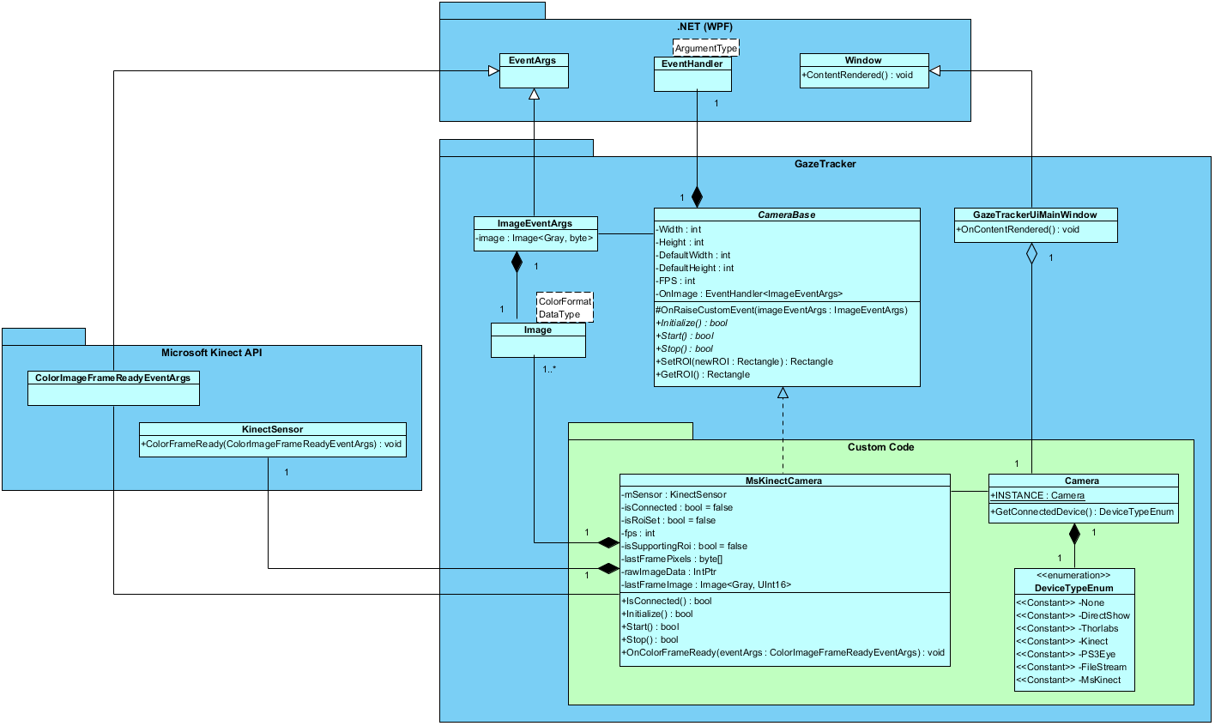

Figure - High level design of GazeTracker software modifications

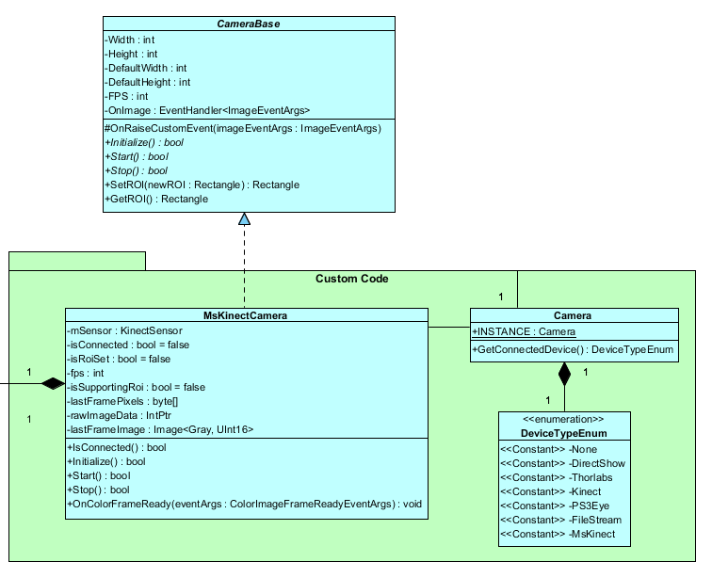

Figure - Primary additions/modifications to the GazeTracker software

The GazeTracker framework provides an abstract base class named CameraBase which defines attributes and operations related to initializing connection to and obtaining data from a generic camera system. For this project, CameraBase was extended in the MsKinectCamera class. This class used functionality provided by the Microsoft Kinect API (<http://www.microsoft.com/en-us/kinectforwindows/develop/>) to communicate with an attached Kinect sensor. The Kinect sensor contains an infrared (IR) camera feed, which is accessed by passing the *InfraredResolution640x480Fps30* value into the sensor’s ColorStream.Enable() method. The code snippet in Figure 7 shows this call.

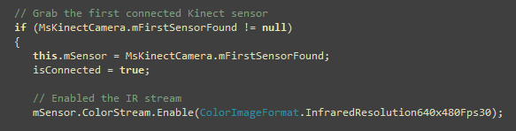

Figure - Kinect IR camera initialization, code snippet

Once the camera is initialized and enabled, the Microsft Kinect API will call the *OnColorFrameReady()* event handler every time a new frame image is available from the camera stream. In this system, that frame must then be converted to an 8-bit grayscale format before being passed to the GazeTrackerUiMainWindow for processing by the GazeTracker system. The implementation of this functionality is detailed in Figure 8.

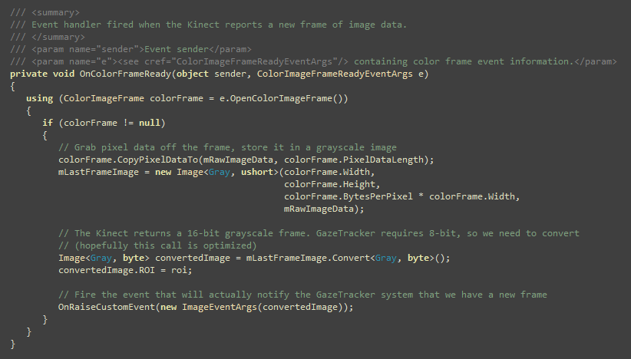

Figure - Code involved with Kinect IR camera frame management, code snippet

Finally, the sequence diagram shown in Figure 9 illustrates the components and methods involved with initializing the Kinect infrared camera and obtaining its frame buffer information.

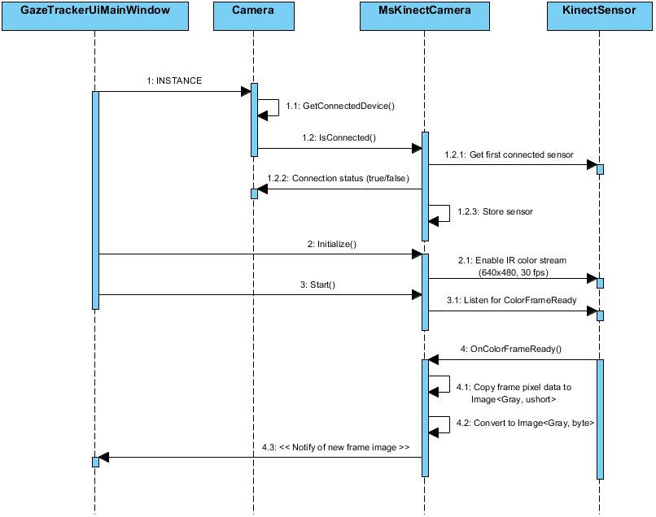

Figure - Sequence of Kinect camera initialization and frame rendering

### Results

Several iterative tests were conducted on the Kinect-based eye tracking system. Attempts were made to digitally zoom the input stream on the user’s eye(s) within the software. Eventually it was determined that a sufficient track could not be maintained by the GazeTracker software using the Kinect video input, at least in the timeframe allowed by this project. The Kinect-based system was abandoned and the SMI RED system was chosen as the target eye tracking system to move forward with development of the primary gaze-based application.

It should be noted that, while this project could not proceed with using the Kinect system as an eye tracker, other teams have recently developed hardware-based solutions to focus the Kinect camera as input into a software eye tracker. One such system is the *NUIA eyeCharm for Kinect*®, a crowd-funded project hosted on Kickstarter (<http://www.kickstarter.com/projects/4tiitoo/nuia-eyecharm-kinect-to-eye-tracking>).

## Phase 3 – Gaze-based virtual globe software

An application was developed which presents the user with a virtual globe environment. The application exposes a user interface (UI) overlay for zooming and panning that globe using gaze. Based on previous research into gaze-based control in virtual environments (XXXXXX), the user interface developed here was both *discrete* and *continuous* (referred to as XXXXX in XXXXX research).

### Software Design

This application was developed in Java utilizing several third-party libraries. The primary display library was World Wind, a 3D interactive globe API developed by NASA [XXXXXX]. Another library was the student-developed Eye Tracking API [XXXXXX]. This Java-based API allowed filtered access to the raw gaze input provided by the SMI eye tracking system. The software opens a UDP socket and receives raw 2D gaze points at a rate of 250Hz. The software then filters the input to smooth the incoming points, before presenting that data to the user interface layer.

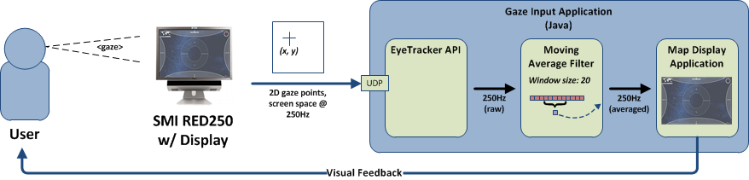

Figure - High level diagram of gaze input application design

#### User Interface Design

As mentioned the user interface interaction implemented here was based on Stellmach’s *discrete* x *continuous* design. [XXXXX] The controls were *discrete* in that they required explicit activation through leaving one’s gaze within the control area for a certain length of time. This length of time was set to five seconds in order to avoid accidental activation during saccades (a gaze-input phenomenon known as the “Midas Touch” problem). The controls were *continuous* in that, once activated, they would continue executing their respective action until the user explicitly removed their gaze from the control region, as opposed to executing one single activation.

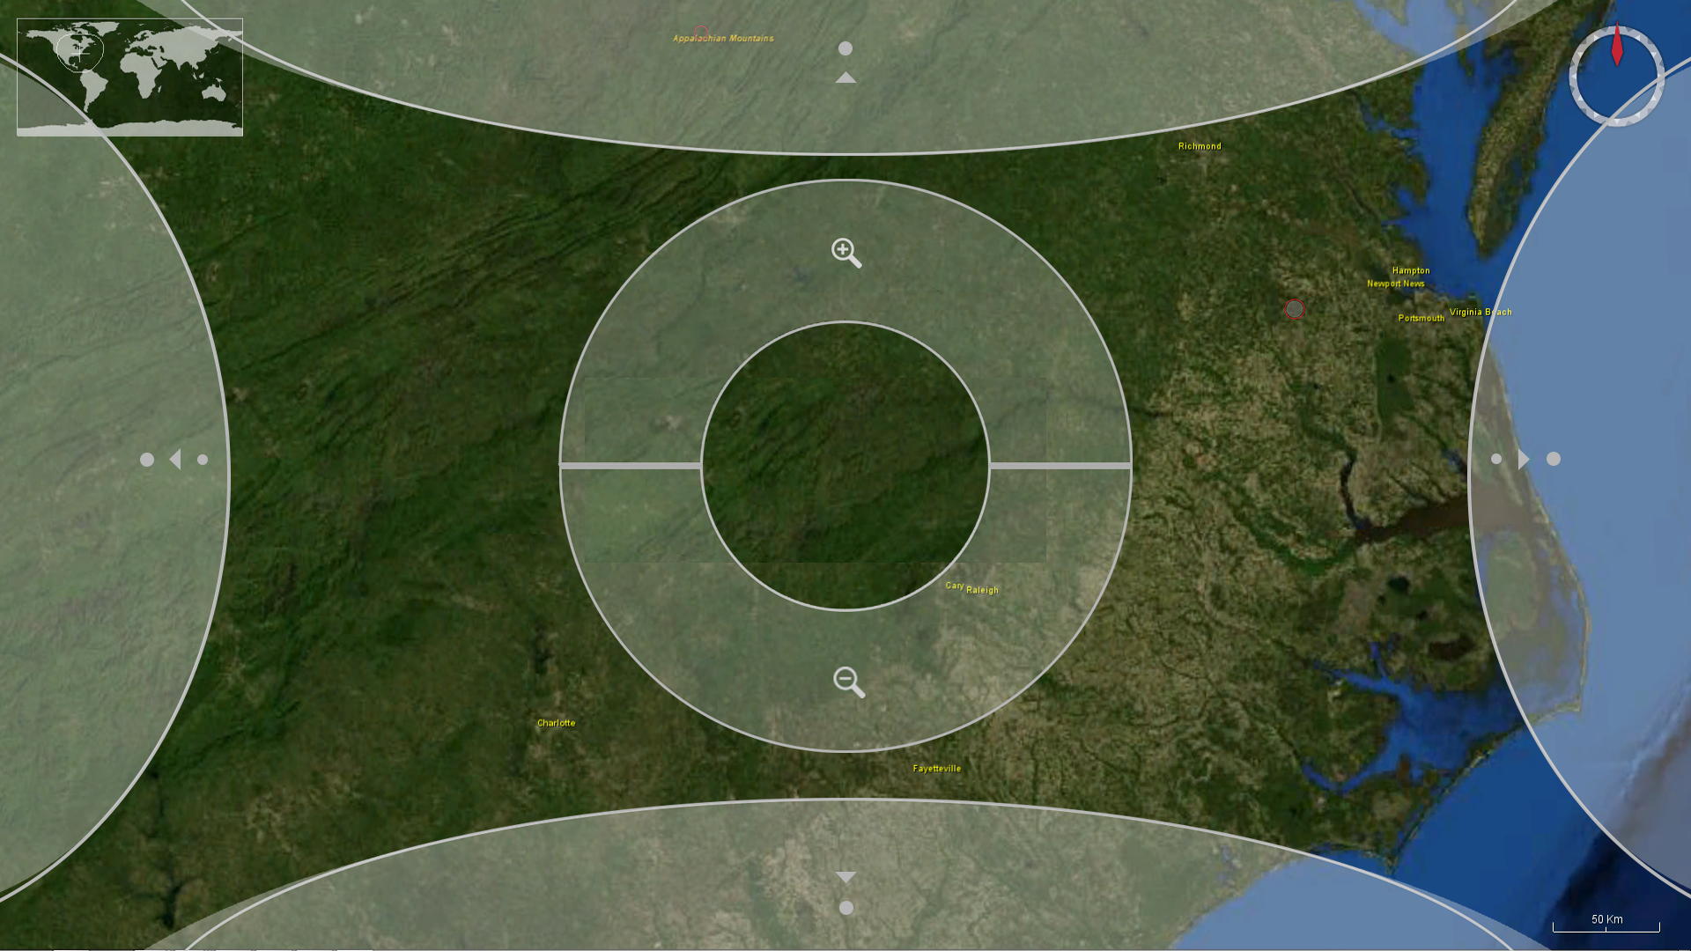

Figure - Gaze UI overlaid on globe

The visual design of the UI overlay was also based roughly on the UI overlay presented to users in Stellmach’s research (XXXXX), although the specific layout of various controls was different. The controls were presented relatively large, filling a majority of the screen space, but kept at a 50% or lower transparency level. The interface included controls for 360° panning as well as zooming in and out. The user was made aware of their current gaze location using a small indicator also overlaid on the display (see Figure 12)

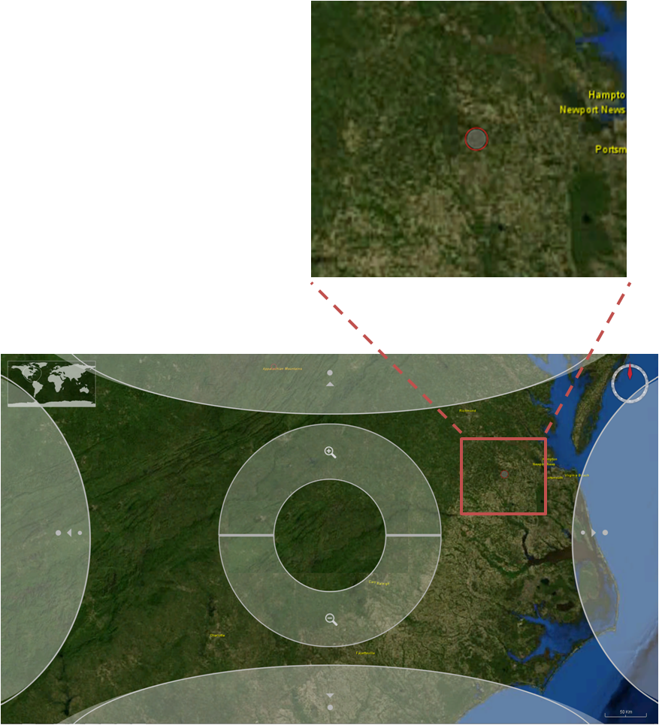

Figure - Gaze input application with gaze cursor shown

Several variations on the layout of the user interface were considered (see figures XXXXX). Eventually an *adaptive* scheme was designed where the user would be presented with an edge-of-screen interface for gross panning at far zoom levels and a centralized UI for fine panning at close zoom levels.

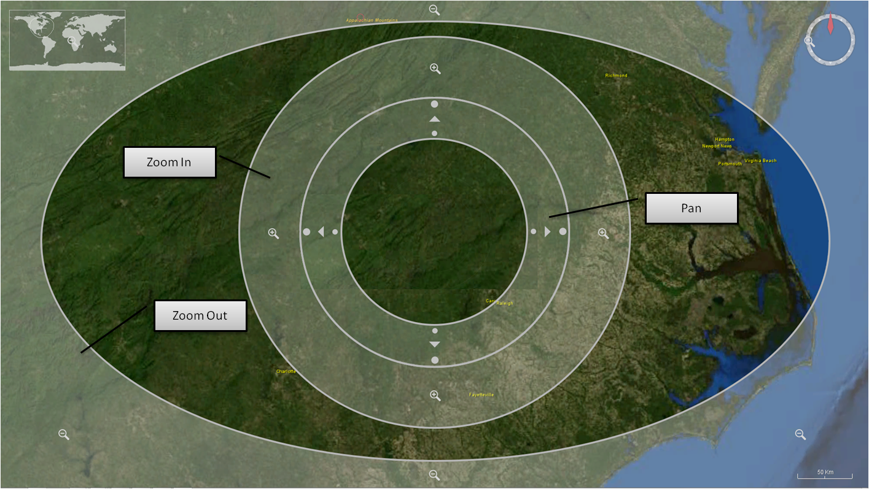

Figure - Previous UI design, with zoom out interface on outer edge of screen

In the final design of the gaze user interface, the default pan controls were placed on the outer edge of the screen as shown in Figure 14. This decision was based on the work of Adams, et al as mentioned previously and seen in Figure 4.

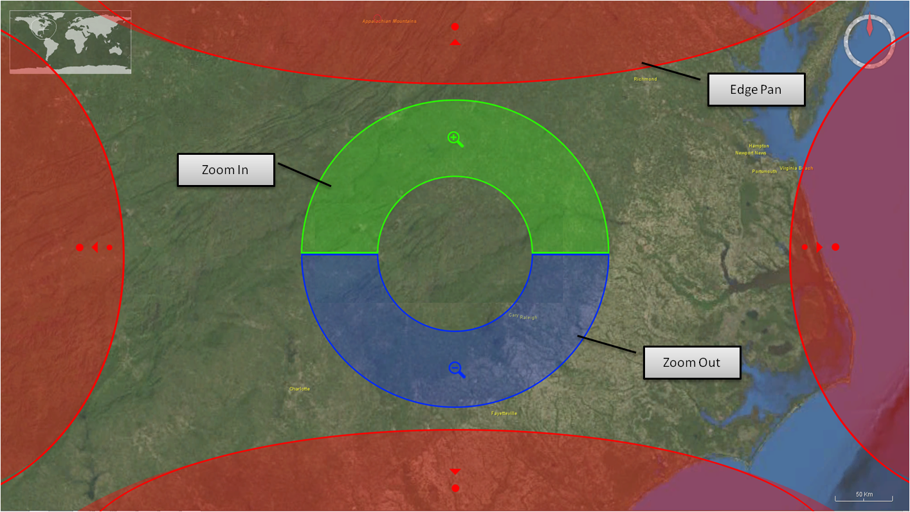

Figure - Final UI design, in "edge pan mode"

However, unlike in Adams’ design, in this design as the user zoomed in the pan interface would eventually swap to a “center pan” mode. In this mode, pan controls were centered within the inner zoom ring as shown in Figure 15. The concept behind this adaptive design was based on an assumption that users would desire a gross, fast pan out larger zoom levels and a fine, slower pan when zoomed in. The center pan mode would be useful for navigating around smaller geographic regions. This was one assumption evaluated during preliminary user testing, to be verified by qualitative participant feedback.

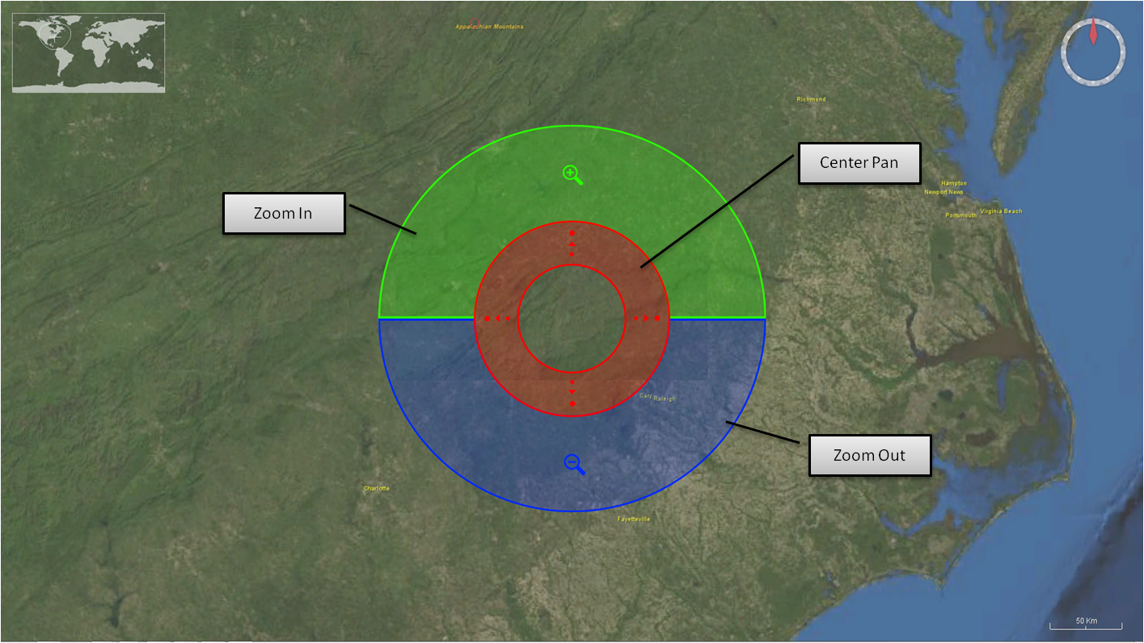

Figure - Final UI design, in "center pan" mode

#### Moving Average Gaze Filter Design

As noted in Figure 10, a moving-average smoothing filter was implemented as part of this software development. Each raw gaze point output by the SMI sensor was sent to this filter and added to a collection. The length of that collection (the “window size”) was configurable on application startup. Each gaze point in the list was averaged, and that averaged was returned as the filtered point for that particular update. This resulted in a much smoother, more accurate track of the user’s gaze than just using the raw output from the SMI system. However, as a window size that is too large would introduce significant lag in the gaze cursor output, the value needed to be tweaked during integration testing. Eventually an averaging window size of twenty (20) samples was found to be ideal.

The figures below illustrate the basics of the algorithm as it was implemented for this filter.

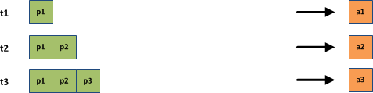

Figure - Moving average filter example, charging

Before producing optimally filtered output, the algorithm must be “charged” with the target number of samples for the averaging window. Until that time, an average of the available samples is taken. Figure 16 shows three time steps in the gaze processing. In time step *t1*, the average value *a1* is simply the first point value *p1*. Subsequently in time steps *t2* and *t3*, the average of available samples is taken to produce a relatively sub-optimal output.

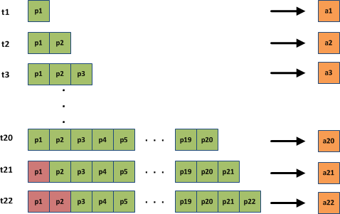

Figure - Moving average filter example, charged

Figure 17 continues with this example, now showing the averaging results in future time steps. In time step *t21*, the sample window has now moved and the resulting average *a21* is the average of *p2* through *p21*. The point *p1* has been dropped from the overall average. At the configured sampling rate of the SMI RED250 system (250 Hz) the moving average window becomes fully charged in approximately 0.08 seconds.

The result of this filter is conceptualized below in Figure 18. What was previously a jittery “cloud” of gaze points becomes a relatively smooth gaze path. Because this system renders the user’s current (filtered) gaze point (see XXXXXX), this has the added benefit to system usability in that it is much less distracting.

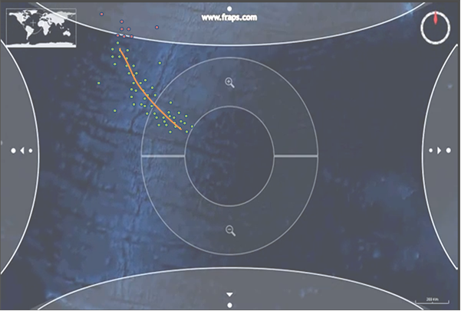

Figure - Improvement of moving average filter (concept)

#### Display Software Design

The design of the gaze input application is composed of two primary components: The EyeTrackerAPI and the WorldWindGazeInput application. The former provides a communication interface to the eye tracking system and an event-based API for interested clients. The latter provides the actual visual and user-input functionality in the form of a World Wind globe and overlaid user interface controls. Figure 19 provides a relatively detailed view of the design of this software system. Here you can see how the EyeTrackerAPI relates to the WorldWindGazeInput package. The following sections will go into detail on specific design components (classes and relationships) and how they function within the system.

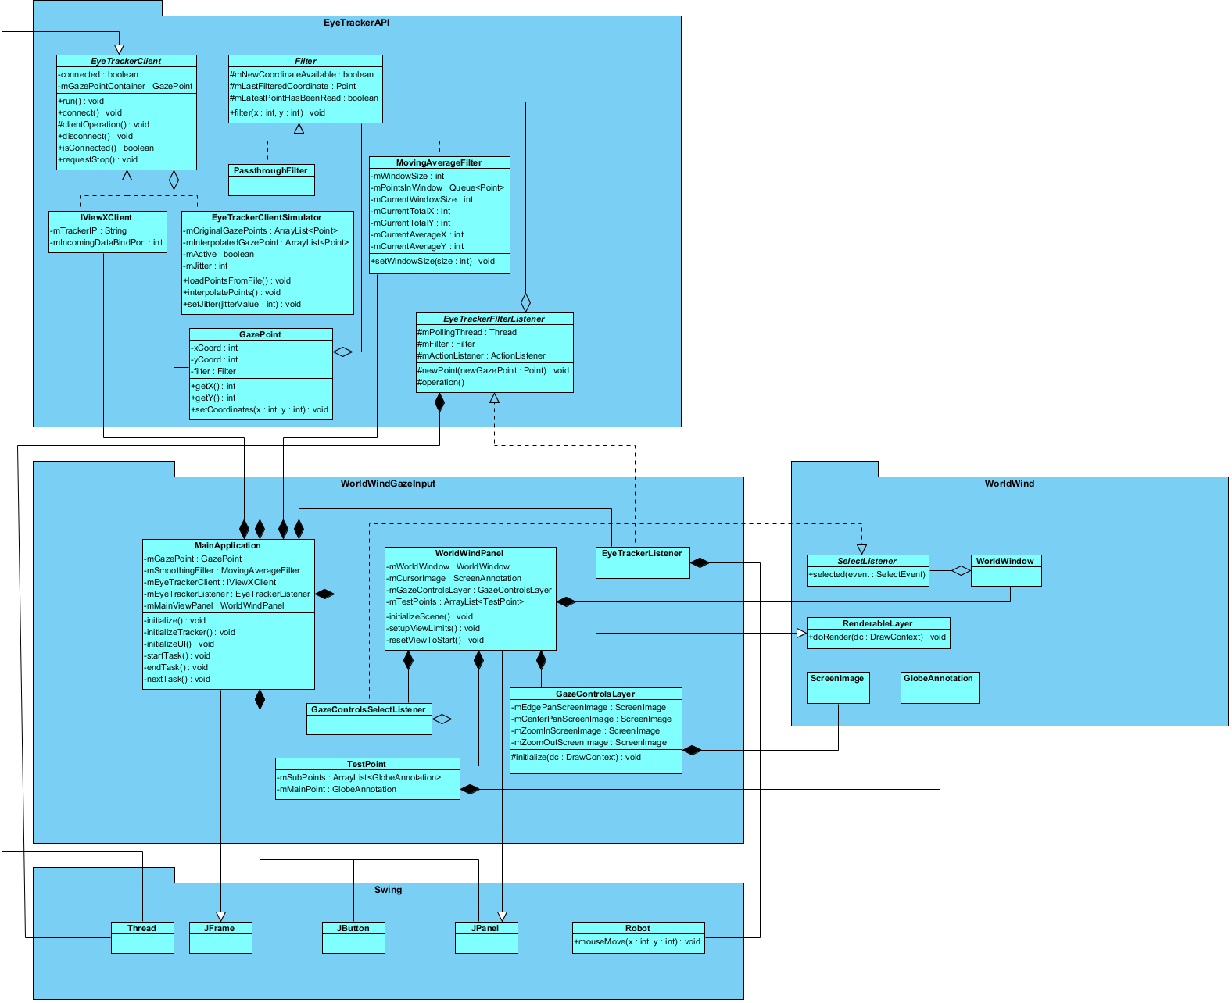

Figure – Detailed design of the gaze input application

As part of this project, the EyeTrackerAPI was used and modified in several ways. This is an API developed by RIT students and available as an open source project hosted on Google Code (<https://code.google.com/p/eye-tracker-api/source/browse/#svn%2Fapi>). Its primary purpose is to provide a Java communication interface for receiving raw gaze data from a number of eye tracking systems. Systems supported by the API include the SMI RED250 and the open source ITU GazeTracker software.

The two primary components in the design of the EyeTrackerAPI are the *EyeTrackerClient* and the *Filter*.

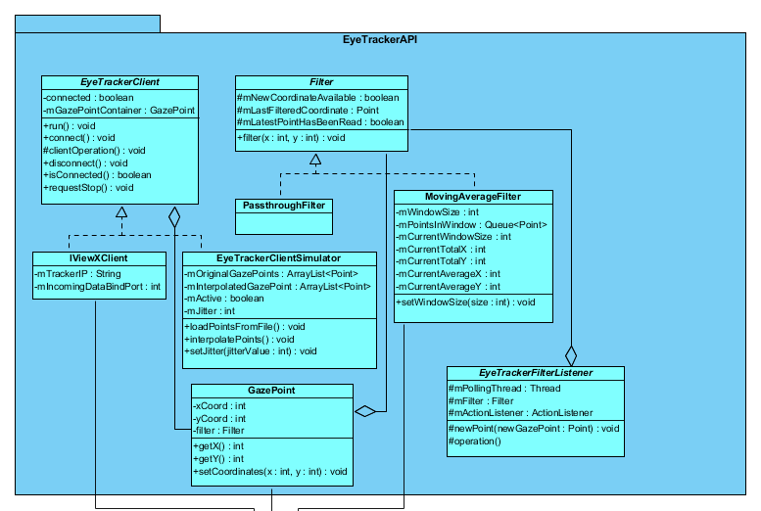

Figure - Detailed design of the EyeTrackerAPI package

The *EyeTrackerClient* is an abstract class which defines generic attributes and operations related to connecting to an eye tracker source. The specific source is undefined at this interface level. As shown here, *IViewXClient* is one implementation of *EyeTrackerClient* and provides specific functionality for connecting to the SMI RED250 system (the data interface provided by SMI is referred to as “iViewX”). The concrete *IViewXClient* class defines parameters for connecting to the SMI system such as IP address and bind port. As defined by the *EyeTrackerClient* interface, the *clientOperation()* method is the primary executor for this process. *EyeTrackerClient* extends the Java Thread class, and each implementation executes its respective *clientOperation()* method in a loop on this dedicated thread. The *clientOperation()* method has knowledge of the specific format of gaze data which is output by the SMI system and parses that output to obtain an X,Y coordinate whenever one is sent over the corresponding UDP socket.

You will notice in this design that an additional capability was added to support simulated gaze data in the form of a comma-separated-value (CSV) input file, in the form of the *EyeTrackerClientSimulator* class. This was done to support testing of the gaze input UI prior to integrating with an actual eye tracking system. The *EyeTrackerClientSimulator* class is itself an implementation of an *EyeTrackerClient* interface.

The second primary component of the EyeTrackerAPI, the *Filter,* is an abstract class which defines generic attributes and operations related to performing filtering on two-dimensional coordinates. It provides thread synchronization functionality so that once each point is filtered it can be consumed asynchronously by an interested client. The primary method of operation in a *Filter* implementation is the *filter()* method. This method accepts a single X, Y coordinate as input, performs some kind of filtering functionality using that point, and stores the result in a thread-safe member attribute (*mLastFilteredCoordinate*).

For this project, two specific implementations of the *Filter* interface are of note. Firstly, an extremely simple *PassThroughFilter* was developed. This provides the ability for an interested client application to receive raw, unfiltered data from an eye tracking system. This functionality was previously missing from the EyeTrackerAPI, as a functional filter was always required. The next extension to the EyeTrackerAPI that was developed for this project was the implementation of the *MovingAverageFilter* class. The detailed design of the functionality behind this filter was discussed in the previous section of this document.

The relationship between an *EyeTrackerClient* implementation and a *Filter* implementation follows a producer-consumer pattern. An *EyeTrackerClient* contains a reference to a *GazePoint* data structure, which is filled by its *clientOperation()* method during operation. This is a thread-safe structure. This same *GazePoint* instance is then queried by a *Filter* implementation (the consumer in the producer-consumer model) when the EyeTrackerClient thread yields after receiving a new gaze point. Both the *Filter* and the *EyeTrackerClient* classes are meant to be initialized with an instance of an existing *GazePoint*, which is itself initialized and owned by the client application (see the *MainApplication* class in Figure 19).

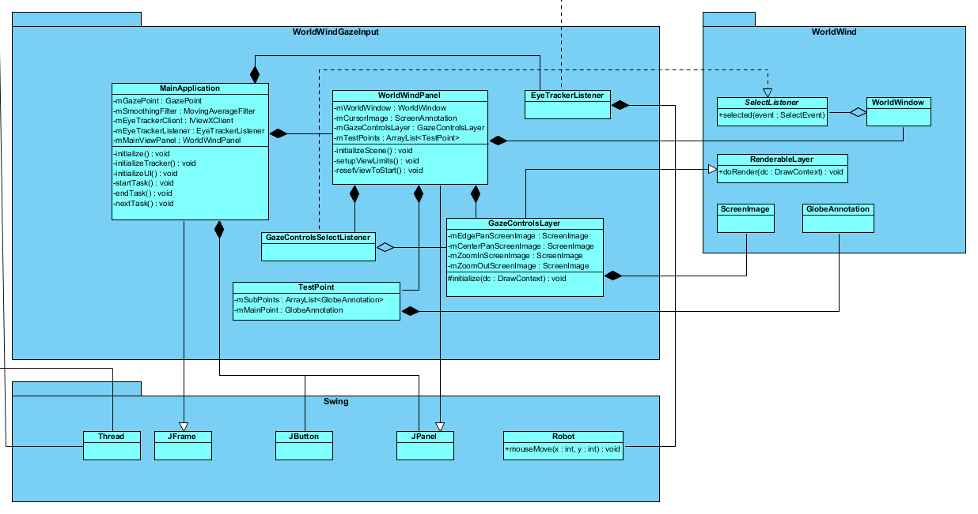

Figure - Detailed design of the WorldWindGazeInput package

The WorldWindGazeInput application is composed of several primary classes as shown in Figure 21, with some minor complementary classes which are relatively trivial and not shown in detail here. This portion of the project was also made open source, as a sub-project under the EyeTrackerAPI project in Google Code (<https://code.google.com/p/eye-tracker-api/source/browse/#svn%2Fapps%2FWorldWindGazeInput>).

The *MainApplication* class extends from JFrame, which gives it the ability to function as the main window in a desktop application through the Java Swing Application Framework. *MainApplication* owns and shares a lifetime with several key components of the system, including an *EyeTrackerClient* implementation and a *Filter* implementation (an *IViewXClient* and a *MovingAverageFilter* respectively). The application class begins operation by initializing these components to establish its connection with the SMI eye tracking system and listening for its output.

*EyeTrackerListener* is a concrete implementation of the *EyeTrackerFilterListener* interface. It is owned and initialized by *MainApplication*, which passes it a reference to the *MovingAverageFilter* previously created. In this way, when the *MovingAverageFilter* has a new (filtered) gaze point to report to *EyeTrackerListener*, that class can then handle actually moving the operating system cursor on the screen. This is accomplished using a reference to the Swing *Robot* class, specifically through the *mouseMove()* method call as shown in Figure 21.

The *WorldWindPanel* is the primary visual component of the application. It extends the Swing *JPanel* class, which allows it to be rendered within a *JFrame* container (the *MainApplication*). This class performs initialization and management of all the visual rendering components of the application, including the globe view and the user interface. It contains an instance of the *WorldWindow*, which is the primary rendering component of the World Wind geospatial rendering library. It handled creation of the *GazeControlsLayer*, as well as adding it to World Wind’s model for rendering by the World Wind rendering system. Because *GazeControlsLayer* extends from *RenderableLayer*, it can be added to the WorldWindow and be managed by the World Wind rendering framework. Detailed information about World Wind visualization and the rendering pipeline is beyond the scope of this document. More information can be found at the official NASA World Wind web site at <http://goworldwind.org/>.

### Phase 4 – User Evaluations

The primary research questions in evaluating this system were two-fold. Firstly from a quantitative perspective: Were the participants *physically able* to use the interface to perform the tasks, and how effective were they? Secondly from a qualitative perspective: How natural or intuitive did the gaze-based UI overlay interactions feel to the users? Did they *feel* they were effectively navigating the map and that the system was responding well to their intent?

#### Participants & Recruiting Methods

Participants were recruited using a combination of email solicitation and posts to an online community bulletin board. Potential participants were asked to fill out an online screening survey (see appendix XXXXX). This identical survey also served as a background questionnaire given to participants immediately prior to test activities. However, the online version included fields requesting the participants’ email address in order to contact them to take part in the study.

Metrics describing the demographics of test participants are outlined in the figures below.

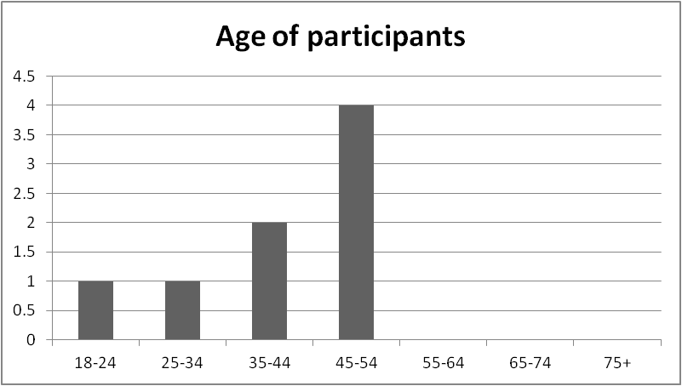

Figure - Age of test participants

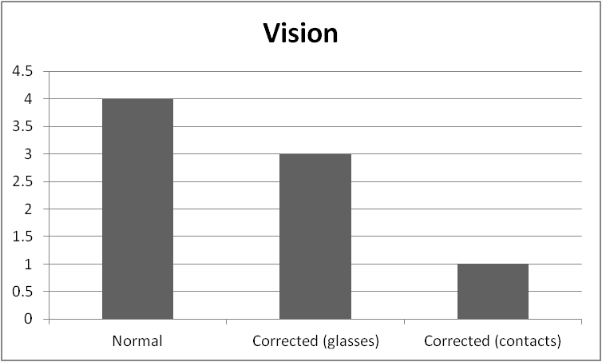

Figure – Test participant vision quality

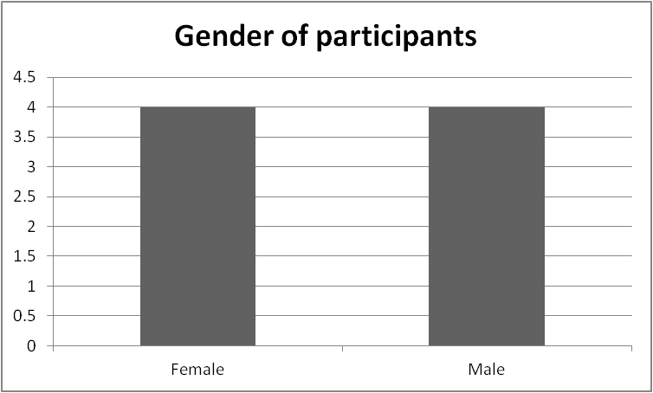

Figure - Gender of test participants

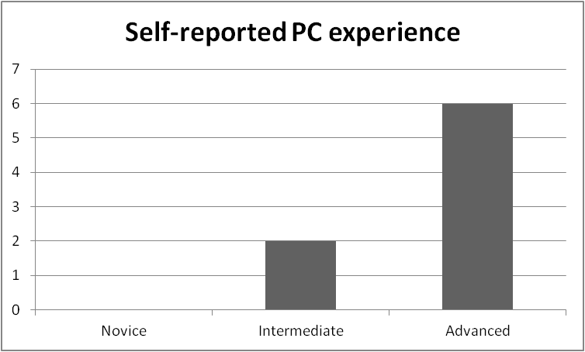

Figure - Reported level of experience with personal computers

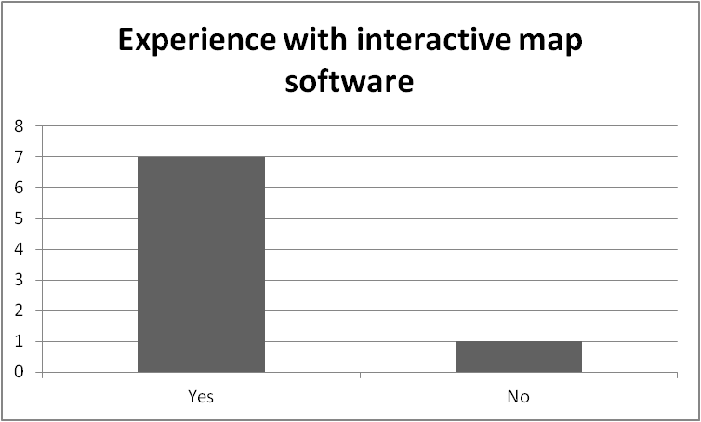

Figure – Test participant experience with map software

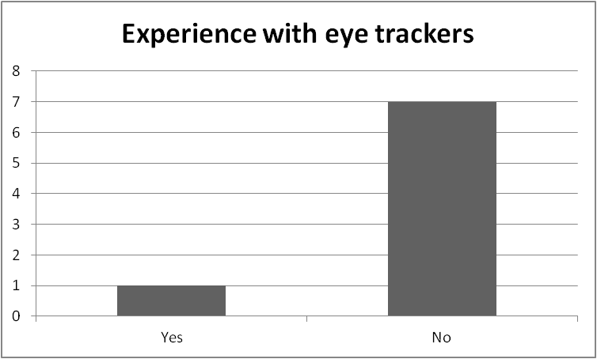

Figure – Test participant experience with eye trackers

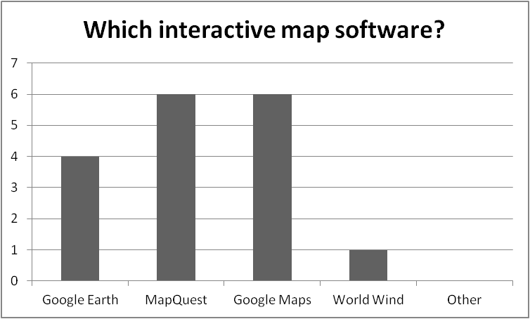

Figure - Type of map software experience

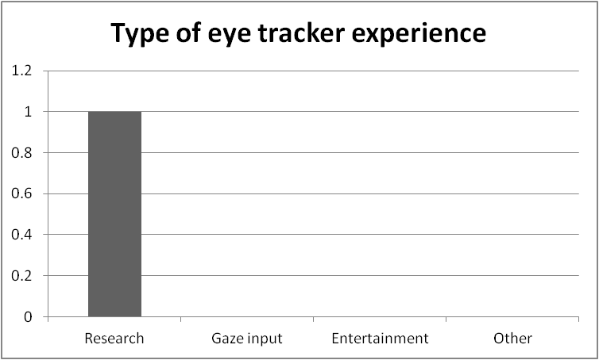

Figure - Type of eye tracker experience

As shown here, among the eight participants there was an equal distribution of males and females. The median age range was between 40 and 50. Half of participants reported having normal vision (or at least did not wear corrective lenses during the test). A majority of participants (six out of eight) reported having an advanced level of experience using personal computers. However, only one person had had prior experience with eye tracking systems. That person’s experience was primarily in the role of a student researcher. Most participants (seven out of eight) reported having experience with some kind of interactive mapping software, with MapQuest and Google Maps sharing the highest number of participants with experience (six each).

#### Test Procedure

Participants were first asked to fill out a background questionnaire in order to verify their personal and experiential information (as well as to remove any identifying information like email address from the responses). A copy of that questionnaire can be found in XXXXXXXXXXX. An introduction script was then read to the participant by the test moderator (see Appendix XXXXX). The purpose of the script was to make sure that each participant heard the same instructions and information concerning the system.

Participants then completed a 9-point calibration of the eye tracking system. They were asked to remain as still as possible and to follow a red dot as it animated to nine discrete points on the screen. The result of this calibration was presented to the test moderator as X and Y angular degree offsets. The target for this test was that an angular accuracy of < 1° (one degree) in both the X and Y directions be achieved and maintained throughout. Participants were given the opportunity to re-calibrate the system after each task if they felt the accuracy was too low.

Figure 30 shows the initial calibration values for each participant.

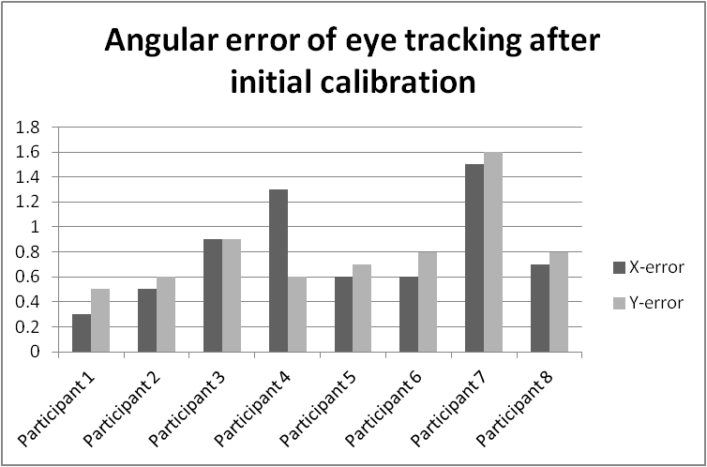

Figure - Initial calibration accuracy of each test participant

Note that two participants (participants 4 and 7) were not quite able to achieve < 1° accuracy. However the accuracy was fairly close to the target and it was determined acceptable to attempt using the system. Performance did not seem to suffer significantly for those two participants, as they were generally able to make real-time corrections to their gaze to effectively activate the user interface.

After initial calibration, participants were presented with a reference map. This was a printed sheet of paper showing a complete map of the earth, with target labeled regions shown. Target regions were labeled A, B, C, D, and Z. This reference map can be found in Appendix XXXXXXX.

Participants were then introduced to the map application for the first time. The moderator explained, generally, the layout of the application and how it would be used to navigate.

The participant’s primary task was to pan and zoom to each point of interest. Once zoomed in, the point split into four yellow sub-points. This was also the trigger for the UI to transition from the edge-of-screen panning to the center-of-screen panning. The participant navigated to each sub-point until all four were green, then zoomed out. Once the camera was zoomed out completely, the task was complete.

Participants were fist asked to navigate to a practice point (labeled Z). During this practice no task timing information was collected, and the moderator walked them through the navigation process step-by-step if needed.

Once the practice point was completed, participants were then asked to turn over index cards placed in front of them one-by-one. On each index card was written the letter label of a particular point-of-interest.

The task ordering (A, B, C, D) was changed from one participant to the next using a Latin square design. This was meant to account for any learning bias in the gaze interactions. The camera was re-positioned to a neutral starting point for each task, roughly equidistant from all target points at the furthest zoom level.

< REFERENCE MAP WITH STARTING POINT SHOWN >

After all four points had been reached, the primary tasks were complete. Participants were then asked to fill out two surveys to collect qualitative feedback. The first survey was a slightly modified version of Adams’ XXXXXX (see Appendix XXXXX). The second was a standard System Usability Scale (SUS) survey. The participant was then debriefed and any open questions were discussed with the moderator.

#### Quantitative Test Results

< Summary of data collection methods and metrics>

< Task time details >

#### Qualitative Test Results

< General notes and observations >

< Selection of participants comments >

< Gaze Input Survey >

< SUS >

## Conclusions and Future Work